

*July 23, 2020 Edition 4*

Summer has finally begun, and it has been a slow start this year. Everyone has been longing to get out of lockdown and get back to some form of normal. The boating world is anxious to get back on the water and as the COVID restriction start to loosen we are seeing more overnight guests coming into the main Marina. Presently the Port is restricted to 50% transient capacity and we have tried to hold that standard.

# COVID-19 and the Port:

# It is important for everyone to remember that restrictions are still in place and will remain so until the County Health Officer and the San Juan County Council provide new direction. So please wear your mask when in public. Masks are required if you come into any of the Port offices to conduct business. Today the Port received direction that masks will be required to be worn on all docks and common areas in all Port Marinas and facilities. So, stay healthy, wash your hands, and minimize your contacts. It is not over yet.

# JENSEN’S BOATYARD:

# There is a lot going on at Jensen’s right now. There is a covered moorage available for a 28’ boat and you can contact Tami for information on that. The Travel Lift will be undergoing some much-needed maintenance. The Pilings will be sleeved to add additional strength and protect the pilings from damage. Pedestrian traffic from Jensen’s to Shipyard Cove via the walkthrough gates is no longer available to pedestrians. Insurance requirements and safety have driven this change. Restrooms and shower facilities at Jensen’s will continue to be maintained by Port staff.

# SHIPYARD COVE MARINA:

# The Port has established a fabrication shop at Shipyard Cove. We will be manufacturing our own dock floats to replace those that are beyond their life span. The Port can save between one-third and half the cost of a commercially made dock float by doing the work ourselves. We have also purchased a new Butt welder for that purpose, and you will see stacks of HDPE pipe that will be used in the construction of the new docks.

# AIRPORT:

# This fall the Airport will be involved in rehabilitating the runway, taxiways, and aprons by sealing the cracks that have developed over time.

# MAIN MARINA:

# The main Marina has seen several significant changes in the las three months since our last edition. We have a new trash compactor and the water feature (pond) has been restored and is now operational. There are new tents on the main Marina pier available to rent for artists or other vendors. The Port has five of them available and two are located on the pier now. The Port Maintenance team has also been restoring the House Posts located in Fairweather Park in the Main Marina.

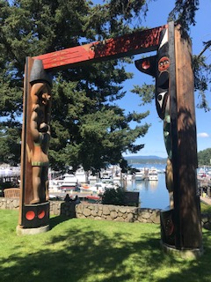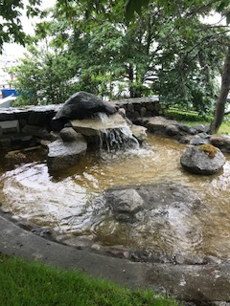

House Posts Main Marina pond

# ADMINISTRATION:

# The Port has converted our storage facility near the south end of the airport from Port storage to commercial storage. We have a few 10X10 and 10X20 units available for rent so if you are interested please give Randy a call at 298-7737.

# Kiosks are available for Lease:

The Port has three 10’x12’ Kiosks available for seasonal or yearly leasing. These building are suitable for a small start-up business. The Kiosks rent for $400 per month for seasonal leases and $300 per month for annual leases. The buildings have metered power available and are located on Mullis St. adjacent to Bakery San Juan. Contact Randy at [randye@portfh.org](mailto:randye@portfh.org) if interested.

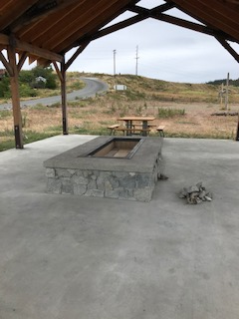

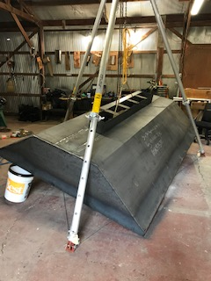

Heat Shield for Jackson’s Beach Shelter New Jackson’s Beach Shelter fire pit

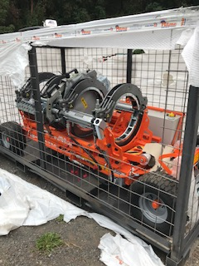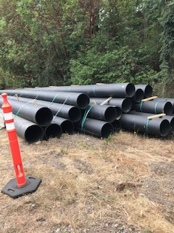

# Butt welder 18” HDPE pipe for dock pontoons

# The real change for us at the Port is our ability to fabricate our own docks, and dozens of other projects that have been routinely outsourced. The maintenance section has added staff that have exceptional skills in welding and fabrication. You will see their handiwork everywhere you look.

# Sign up for Auto Pay!

Receive your choice of a FREE Mug, Chico Shopping Bag, or Port of Friday Harbor License Plate Holder when you sign your Port Account up for Auto Pay! Please call the Port Office (360) 378-2688.

Port Contact Information:

Main Port Office (360) 378-2688

Shipyard Cove: (360) 378-2688

Friday Harbor Airport: (360) 378-4724

Jensen’s Shipyard: (360) 378-4343

Security (360) 317-8672 after 5pm [contactus@portfridayharbor.org](mailto:contactus@portfridayharbor.org)